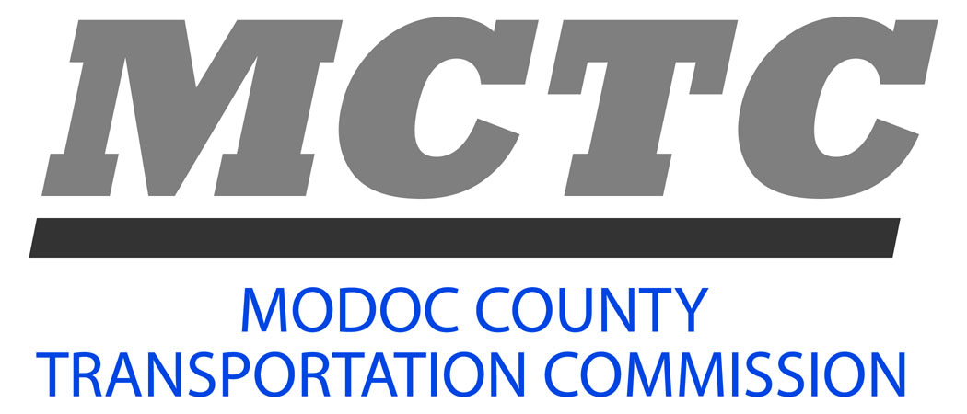
108 S. Main Street
Alturas, CA 96101-3936
(530) 233-6410 Phone

Meets Regularly

First Tuesday of

Even Numbered Months at 1:30 p.m.

Commissioners

John Dederick
Chairman

City Representative

Kathie Rhoads

Vice Chair

County Supervisor III

Paul Minchella
Commissioner

City Mayor

Ned Coe
Commissioner

County Supervisor IV

Jodie Larranaga

Commissioner

City Councilmember

Mark Moriarity
Commissioner

County at Large Citizen

Shane Star
Alternate

County Supervisor I

Brian Cox

Alternate
City Councilmember

Staff

Debbie Pedersen
Executive Director

Michelle Cox
Accountant 1

Kathy Tiffee
Executive Assistant Secretary

Agenda

Regular Meeting

Sage Stage Conference Room

108 S. Main St. Alturas

February 3, 2026, at 1:30 p.m.
Teleconference Number 1-858-222-1450
Meeting ID 8042822
- Call to Order
- Pledge of Allegiance
- Introductions – guests and visitors
- Public Forum –
Citizens may address the Commission with matters that are related directly to Commission responsibilities. If any matters call for action by the Commission, they will be placed on subsequent agendas. Because the Chairman may limit speakers to five (5) minutes each, citizens are encouraged to contact the Chairman or staff for assistance before the meeting.
- Confirm Agenda Action
- Consent Agenda Action
- Approve the minutes from the MCTC meeting on 12/02/25.
- Financial transactions 11/01/25 through 12/31/25.
- Year to Date expenditure report through 12/31/25.
- Regular Business
- Transportation Development Act Findings of Apportionment. Information
- Consider adopting Resolution 25-01 rev 2024/25 Budget (mid-year). Action
- Consider accepting the 2024-25 Fiscal Compliance Audits Action
- Consider authorizing the Executive Director to open an investment account for the SB 125 funds. Action
- Draft 2026/27 Overall Work Plan Information

- Agency Updates and Project Reports Information/Discussion
  - City of Alturas Public Works Department
  - Modoc County Road Department
  - Caltrans District 2
  - Modoc County Transportation Commission
- Staff Update, Correspondence and Calendar Information
Address outstanding issues, correspondence, information, and materials received.
- Conflict of Interest (700 Form) due April 1, 2026
- Future dates and events of interest.
- Adjourn until next MCTC Regular meeting Action
Tuesday, April 7, 2026, at 1:30 p.m., or soon thereafter, in the Sage Stage Conference Room at 108 S Main Street, Alturas, CA.

